The Medicinal Chemistry Seminar Series presents:

Dr. Jackie von Salm
Co-founder and Chief Science Officer of
Psilera Bioscience
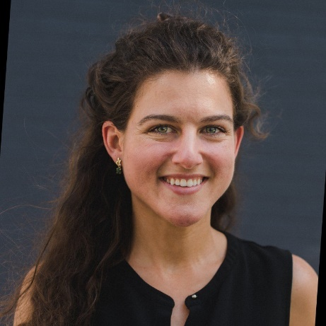
“Re-Imagining Tryptamine Psychedelics for Mental Health Disorders”
1544 North University Building
11:00am Thursday, October 26th, 2023

Abstract:
Natural products have served as blueprints for drug discovery and medicine throughout human history with more than 65% of FDA-approved medications owing their origin to compounds found in nature. A heightened societal interest in psychoactive natural products such as cannabinoids, tryptamines, and phenethylamines has catalyzed studying these compounds after years of dormant research. Of the known psychedelics, tryptamines such as psilocybin (mostly found in Psilocybe mushroom species) and N,N-dimethyltryptamine (DMT; typically found in mimosa tree bark or ayahuasca tea, Psychotria viridis) are shown to have promising activity in mental health and other central nervous system disorders with multiple clinical trials ongoing around the world. Although promising, these compounds have significant limitations including intense hallucinations due to serotonergic activity at the 5-HT2A receptor and moderate cardiotoxicity (hERG and 5-HT2B). Our goal at Psilera is to expand our current chemical and pharmacological knowledge of these molecules and make therapies that are more accessible to diverse patient populations. Our group has designed dozens of structural analogs with unique partial and inverse agonism at various serotonin receptors with minimal off-target effects according to in vitro and in vivo screening. The most promising candidate is a psilacetin (4-AcO-DMT) derivative shown to have anxiolytic properties, enhance learning and memory, and decrease alcohol consumption in addicted mice.

