The Medicinal Chemistry Seminar Series presents:

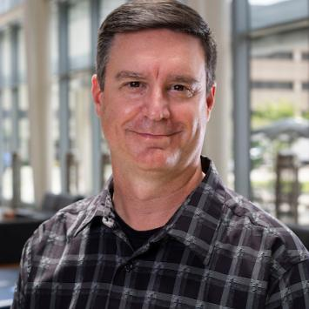
Dr. Thomas Prisinzano
Director of the Drug Discovery & Development Core, University of Kentucky
“Development of Synthetic Opioid Rescue Agents”
1544 North University Building
11:00am Thursday, November 9th, 2023
https://umich.zoom.us/j/98210712745
Meeting ID: 982 1071 2745
Passcode: medchem
Abstract:
Fentanyl is a synthetic opioid that is approximately 100 times stronger than morphine and is used for the treatment of pain, as well as an adjuvant for anesthesia. It is also considered an incapacitating agent, a chemical that produces a disabling condition that persists for hours to days after exposure has occurred, such as in an unexpected chemical attack. As an opioid, fentanyl depresses the central nervous system and respiratory functions, and can be lethal by respiratory depression. Due to its high potency, ingestion of just a few milligrams of fentanyl or other synthetic opioid can be deadly to an opioid naïve individual. Furthermore, first responders at a chemical attack site who encounter free base fentanyl analogues are at significant risk for life-threatening toxicities. Currently, there are three opioid antagonists available on the market that have potential to reverse the effects of fentanyl, namely naloxone, naltrexone, and nalmefene. The most used is naloxone which is approved for administration by a variety of routes, including intravenous, intramuscular, subcutaneous and intranasal. However, recent reports suggest that higher doses or repeated dosing of naloxone (due to recurrence of respiratory depression) is required to reverse fentanyl-induced respiratory depression. In addition, a growing body of evidence indicates that high-potency synthetic opioids like fentanyl exert behavioral and physiological effects through both opioid and non-opioid receptors, including noradrenergic receptors. This presentation will highlight our current research program aimed at identifying an improved synthetic opioid rescue agents.

