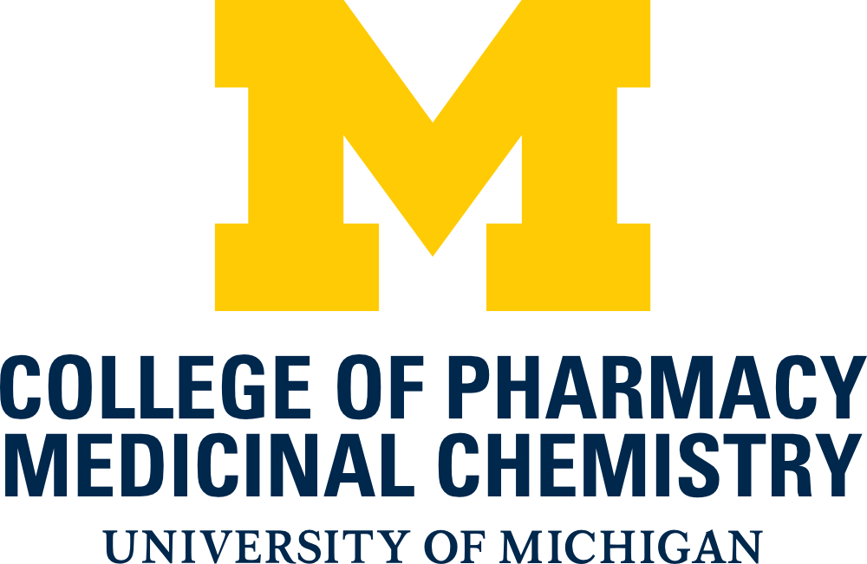

Medicinal Chemistry
IDP Forms

Table of Contents

Academic Progress Form 3
Research Rotation Interview Form 4
Research Rotation Evaluation Form 5
First Year Progress Evaluation Form 7
Mentor Assignment Form 9
Mentoring Agreement Form 10
MC 740/741 Evaluation Form 11
Prelim/Candidacy Examination Evaluation Form 12
Graduate Student Travel Funds Request Form 13
Annual Dissertation Committee Meeting Evaluation Form 14
Data Meeting Form 16

Medicinal Chemistry Academic Progress Form

Name ________________ Date of last Relevant Degree/Major _______________________

Previous Degree/Institution ____________________________________________________

Score/%ile | ACS Placement Exam
 | Organic Score
 | Biochem Score
Tracks:
BIOCHEMICAL=Bc

BIOPHYSICAL=Bp
BIOINFORMATIC=Bi

ORGANIC=O

573 Advisors: 1st ______________, 2nd ______________, 3rd (optional)* ______________

Milestones Dissertation Committee Members

DATE(S) | MILESTONE |  | Chair:
 | Rotation paper 1
 | Rotation paper 2
 | 1st Year Evaluation
 | MC 740
 | Prelim Exam
 | Adv. to Candidacy
 | Diss Committee formed
 | Third Year Seminar
 | Annual Comm. Mtgs
 | Data Meeting
 | Defense

Coursework

Electives
 | Cr. | Grade

Required |  |  |  |  | Track-Specific
# | Credit |  | Grade |  | # | track | Credit | Grade
Medicinal Chemistry |  |  |  |  | Biophysics
532 | 3 |  |  |  | 520 | Bp | 3
533 | 3 |  |  |  | 521 | Bp | 3
534 | 3 |  |  |  | Chemistry
573 | 3 |  |  |  | 541 | O | 3
573 | 3 |  |  |  | 542 | O | 3
573* | 3 |  |  |  | 543 | O | 3
660 | 1 |  |  |  | Chemical Biology
740 | 1 |  |  |  | 501 | Bc | 3
940 | 1 |  |  |  | 502 | Bc | 3
990 | 2-9 |  |  |  | Bioinformatics
995 | 8 |  |  |  | 527 | Bi | 4
Biol Chem/Chem Bio |  |  |  |  | 575 | Bi | 3
550/501 |  | 3
Chemistry
540 | 3
GPA by Term
Yr./Term | GPA/Sem | GPA/Cum

Medicinal Chemistry Research Rotation and Mentor Interview/Selection Form (MC573)

CONTACT MED CHEM OFFICE FOR HARDCOPY OF THIS FORM

Name:
Interviews

Print Name / Signature / Date Print Name / Signature / Date

Print Name / Signature / Date Print Name / Signature / Date

Print Name / Signature / Date Print Name / Signature / Date

Print Name / Signature / Date Print Name / Signature / Date

Med Chem 573 Rotation Selections (faculty sign and return form to Med Chem Office)

Term: Fall
Print Name / Signature / Date

Evaluation Submitted to Office (date):
Final Report Submitted to Office (date):

Term: Winter
Print Name / Signature / Date

Evaluation Submitted to Office (date):
Final Report Submitted to Office (date):

Term: Spring
Print Name / Signature / Date (if approved)

Evaluation Submitted to Office (date):
Final Report Submitted to Office (date):

Medicinal Chemistry Research Rotation Evaluation Form (MC573)

Expectations of the student
- Work a minimum of 25 hours/week on a project designed in consultation with your rotation advisor
- Keep an acceptable laboratory notebook describing your experiments and results
- Meet with your rotation advisor at regular intervals (as agreed in advance) to discuss progress and obstacles
- Prepare a detailed report (intro, results, discussion, experimental) at the end of each rotation
- Revise rotation reports based upon feedback from rotation advisor

Expectations of the mentor
- Design an appropriate research project in consultation with the student
- Provide appropriate training/background information necessary for the successful completion of the project
- Provide the resources (space, equipment, supplies, etc.) necessary for the successful completion of the project
- Meet with the student to review progress etc. at regular intervals as agreed in advance
- Review and critique the student’s rotation report and provide feedback for revision to the student
- Provide a written evaluation (below) of the student’s performance (reviewed with the student and submitted to the office by the end of finals for the term)
Any additional mentor expectations should be agreed upon at the beginning of the rotation.
Student:
Rotation Advisor:
Term:
Project Title:

Summary of Research Effort:
Time spent in the laboratory:
Extensive Good Adequate Minimal
Reading relevant scientific research articles:
Extensive Good Adequate Minimal
Intellectual interest in the project:
Extensive Good Adequate Minimal
Student’s capacity to grasp the appropriate concepts and follow the analytical transition between concept and experimental design:
Good Satisfactory Poor
Level of intellectual input into experimental design:
Total passivity Strong creative contribution
all input from Advisor from student

Describe the major research accomplishments of the student during this term:

Are there particular strengths that the student has demonstrated in research?

Do you have specific recommendations to improve that student’s research performance?

I have critiqued the student’s report and returned it for revision. Initials:
Letter Grade: Advisor Signature:

Student
I have discussed this report with my rotation advisor. Signature:

MEDICINAL CHEMISTRY FIRST YEAR PROGRESS EVALUATION FORM

At the end of their first year, the progress of each Medicinal Chemistry Ph.D. student shall be evaluated by the First Year Advisor and the IDP Director. The student’s research rotation evaluations and transcript will be provided to the First Year Advisor for their review. The student and the First Year Advisor shall each independently fill out the attached forms that address the progress made in coursework and research rotations and a plan for the second year. The First Year Advisor will meet with the student to discuss the evaluation. Copies of the advisor and student forms will be shared with the student’s selected Ph.D. mentor and will also be submitted to the Medicinal Chemistry office for inclusion in the student’s permanent file.

Date:

Student: Signature: __________________________

PhD Advisor: Signature: __________________________

First Year Advisor Evaluation
Describe the progress the student has made on their coursework during the first year:

Are there any particular problems that the student has encountered in coursework?

Describe the progress the student has made on their research rotations during the first year:

What do you see as the key things for the student to focus on for the next year?

Student Self Evaluation
Describe the progress you have made on your coursework during the first year:

Are there any particular problems that you have encountered in coursework?

Describe the progress that you have made on your research rotations during the first year:

What do you see as the key things for you to focus on for the next year?

Student Signature: First Year Advisor Signature:

Medicinal Chemistry Mentor Assignment Form (MC573)

Name:

Student’s Assignment of Permanent Mentor (return form to Medicinal Chemistry Office)

Mentor Track:
Print Name / Signature / Date

Co-Mentor (if applicable)
Print Name / Signature / Date

Support Plan for 2nd Year

Fall:

Winter:

Summer:

Approval of Chair

Print Name / Signature / Date

Mentoring Agreement Form: Expectations and Objectives

The mentoring agreement form is part of the CoP Graduate Student Individual Development Plan website, which is accessed via the CoP website by logging into “My CoP”.

Medicinal Chemistry 740/741 Evaluation Form
MC 740 is designed to provide the student with the experience of researching a medicinal chemistry topic from the literature and then proposing novel studies to extend that work. The research topic will ideally be complementary to the student’s thesis research, i.e., not directly related, but relevant enough that increased knowledge in the area will add value to their thesis research. One overarching theme of medicinal chemistry involves the relationship of chemical structure with biological activity and function. Therefore, it is important that the proposal include some discussion of chemical structure. Details about the MC 740/741 procedures can be found in the Medicinal Chemistry Graduate Student Guide. The Committee Chair should submit this form when completed to the Medicinal Chemistry office as soon as possible after the exam.
Student: PhD Advisor:
Committee Chair: Committee Member:
Committee Member: Meeting Date:
Committee’s Evaluation
- Depth and breadth of scholarship (45%)

- Quality, organization and clarity of overall document (25%)

- Feasibility of the ORP (10%)

- Creativity of the ORP (10%)

- Collegiality/working with peers (10%)

Recommended Grade

Committee Chair Signature:

Medicinal Chemistry Preliminary/Candidacy Examination Evaluation Form
The candidacy meeting/examination is designed to evaluate the student’s preparedness for dissertation studies by examining the student’s knowledge in the fundamental scientific disciplines underlying the proposed Ph.D. research and their research skills by assessing their progress to date. Although many aspects of the exam may focus on the research proposal, this is not meant to be a dissertation committee meeting. Candidacy Committee Chairs are advised to focus the exam on the student’s preparation and readiness (including pertinent research skills) for embarking upon their dissertation research. Details about the candidacy exam procedures can be found in the Medicinal Chemistry Graduate Student Guide. The Committee Chair should submit this form when completed to the Medicinal Chemistry office as soon as possible after the exam.
Student: PhD Advisor:
Committee Chair: Committee Member:
Committee Member: Meeting Date:

Please check off that the following were reviewed at the examination:
MC 573 Rotation Evaluations
MC 741 Summary Evaluation
Student’s Transcript

Recommended for advancement to candidacy:
Yes No
Please provide a brief summary of the committee’s assessment:

Committee Chair Signature:

Medicinal Chemistry Graduate Student Travel Funds Request Form

Request Date: Click here to enter text.

Requested by: Click here to enter text.

Name of Meeting: Click here to enter text.

Dates: Click here to enter text.

Location: Click here to enter text.

Are you presenting a paper? Yes No

If yes, list the title and author(s): Click here to enter text.

Is the paper the result of sponsored research? Yes No

Amount requested and estimated total cost: Click here to enter text.

List other sources requested and amounts: Click here to enter text.

Attach a copy of the program, if available.

*Approved: ________________________

Amount: __________________________

Account: __________________________

Date: _______________________

*Total budget with receipts (copies okay) with other support listed must be submitted for reimbursement
MEDICINAL CHEMISTRY DISSERTATION COMMITTEE MEETING EVALUATION FORM

Each Medicinal Chemistry PhD student past candidacy, shall meet minimally on an annual basis with their dissertation committee in their fourth and subsequent years. The student and the student’s PhD advisor shall fill out the attached forms that discuss the progress made since the last meeting, any obstacles identified and a plan for the future. The forms shall be submitted to the committee members one week prior to the meeting. The student will present a progress report and plans for the future to the committee and the committee will provide feedback. The student’s PhD advisor will fill out the Committee Feedback Form and will share this with the student. Copies of the advisor, student and committee feedback forms will be submitted to the Medicinal Chemistry office for inclusion in the student’s permanent file.
Student: PhD Advisor:
Committee Member: Committee Member:
Committee Member: Committee Member:
Meeting Date:
Student Self Evaluation

PhD Advisor Evaluation
These sections are part of the CoP Graduate Student Individual Development Plan website.

Committee Summary Evaluation
Has the student made acceptable progress during the past year?

If no, then what obstacles to progress been identified and what solutions have been proposed?

Has a time frame been set for surmounting the obstacle(s) and has an acceptable and reasonable alternative (e.g., modification of project) been identified?

What should the student to focus on for the next year?

Is the student is “on track” towards completion of his/her PhD? If not, please explain why.

Ph.D. Outcomes Progress

0% 25% 50% 75% 100%
Independence
Expertise
Experimental Skills
Ethics
Fundamental Background
Data Reporting
Communication Skills

Ideally candidate should receive 75% score for EACH outcome before defending their Ph.D. dissertation, although this decision is at the discretion of the dissertation committee.

The candidate MUST have at least ONE manuscript ACCEPTED by a reputable journal AND at least ONE manuscript SUBMITTED (not counting review papers) before defending their Ph.D. dissertation.

manuscripts ACCEPTED or PUBLISHED

manuscripts SUBMITTED.

Student Signature: Advisor Signature:

Medicinal Chemistry Data Meeting
Date:

Student: Signature: __________________________

PhD Advisor: Signature: __________________________

Summary of Final Requirements for Dissertation:

Committee Member: Signature: __________________________
Comments:

Committee Member: Signature: __________________________
Comments:

Committee Member: Signature: __________________________
Comments:

Committee Member: Signature: __________________________
Comments:

Committee Member: Signature: __________________________
Comments:

