Pharmaceutical Sciences is pleased to announce the
Allen J. Sedman Lecture

Wednesday, September 25, 2019
2548 North University Building
4:00-5:00 pm

“Altered Hepatic Efflux Transporters in Liver Disease:
Implications for Precision Medicine”

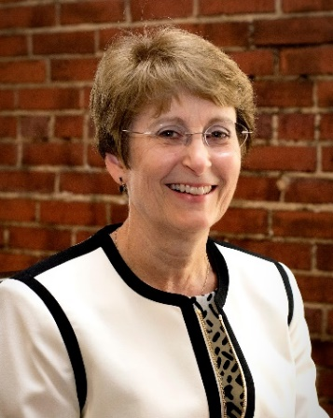
Presented by:

Kim L.R. Brouwer, Pharm.D., Ph.D.
Division of Pharmacotherapy and Experimental Therapeutics,
UNC Eshelman School of Pharmacy
The University of North Carolina at Chapel Hill

Kim Brouwer is Associate Dean for Research and Graduate Education, UNC Eshelman School of Pharmacy, and Kenan Distinguished Professor in the School of Pharmacy and Curriculum in Toxicology at the University of North Carolina at Chapel Hill. Her research program (supported by NIH since 1991) is focused on hepatobiliary drug disposition, hepatic transport proteins, and development/refinement of in vitro models to predict in vivo hepatic drug disposition, drug interactions, and hepatotoxicity. Dr. Brouwer was founding Director of the UNC Pharmacokinetics/Pharmacodynamics Fellowship Program, and is Co-PI of an NIH-funded Postdoctoral T32 Training Program in Clinical Pharmacology. She has mentored a diverse group of trainees (42 clinical pharmacology fellows, 28 postdoctoral fellows/visiting scholars, 34 PhD students, and numerous undergraduate/honors students), and published >230 research papers, reviews and book chapters. Dr. Brouwer is co-inventor of B-CLEAR® and co-founder of Qualyst Transporter Solutions, a UNC spin-off company recently acquired by BioIVT. She is a member of the International Transporter Consortium Steering Committee, a member of editorial advisory boards (Clinical Pharmacology and Therapeutics, CPT Pharmacometrics & Systems Pharmacology, Clinical and Translational Science, AAPS Journal), and has served as a member of the ASCPT Board of Directors (2014-2017), NIH Pharmacology Study Section (1998-2002), NIH Quantitative and Systems Pharmacology Working Group (2010-2012), and co-Chair of the NICHD Pediatric Transporters Working Group (2012-2015). Dr. Brouwer was recognized as an AAPS Fellow in 1998, and received the 2001 PhRMA Foundation Award in Excellence in Pharmaceutics, and the 2018 ASCPT-FDA Abrams Award. In 2009, Dr. Brouwer was named a Kenan Distinguished Professor, one of the highest honors bestowed on UNC faculty.

For more information on the weekly PharmSci department
Seminar series, please view our website:
https://pharmacy.umich.edu/pharmsci/seminars

