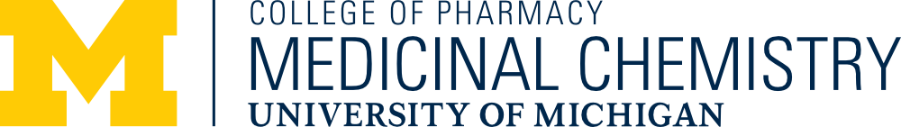

The Medicinal Chemistry Seminar Series presents:

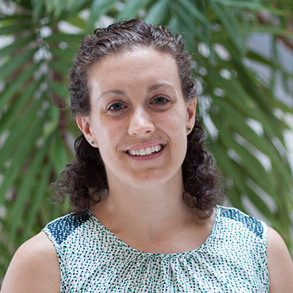
Dr. Alison Axtman
Associate Professor, Strategic Genomics Consortium
University of North Carolina at Chapel Hill
“Understanding the molecular basis of neurodegeneration”
1544 North University Building
11:00am Thursday, November 16th, 2023
https://umich.zoom.us/j/93534145611
Meeting ID: 935 3414 5611
Passcode: medchem
Abstract:
Kinases are an important and highly tractable class of proteins that are targeted by more than 75 FDA-approved, small molecule drugs. Nearly 85% of these approved drugs are for oncological indications. Despite playing essential roles in the brain, targeting kinases to treat neurological disorders has not been the focus of most programs, leaving their potential to alter or halt these diseases unknown. There is an urgent need for new targets and novel approaches for treating neurological disorders. We propose that, based upon their essential roles in many human pathways and in the brain, kinases can be targeted to help patients that suffer from neurodegenerative and neurodevelopmental disorders. Our projects generate high-quality chemical tools, called chemical probes, that allow drug researchers around the world to characterize the suggested role(s) that key kinases play in driving disease pathology. Several examples of programs where we have generated a small molecule chemical probe will be highlighted. Experiments to elucidate disease biology that have been enabled by these small molecules will be presented. We suggest that if our molecules were developed into drugs, they would not just address symptoms like the currently available FDA-approved drugs. Instead, these drugs would augment a disease-causing pathway and would thus slow or halt disease pathology.

